Mediator

Behavioral Design Pattern

**What is a Mediator:**

1. Mediator encapsulates how a set of objects interact with each other. Due to this encapsulation there is a loose coupling between the interacting objects.
2. Typically, an object knows about other object to which it wants to interact with.
3. In mediator pattern this interaction is within the mediator object & interacting objects only know about the mediator object.
4. The interaction can now change without needing modification to participating objects. Changing the mediator allows to add/remove participants in an interaction.

**UML:**

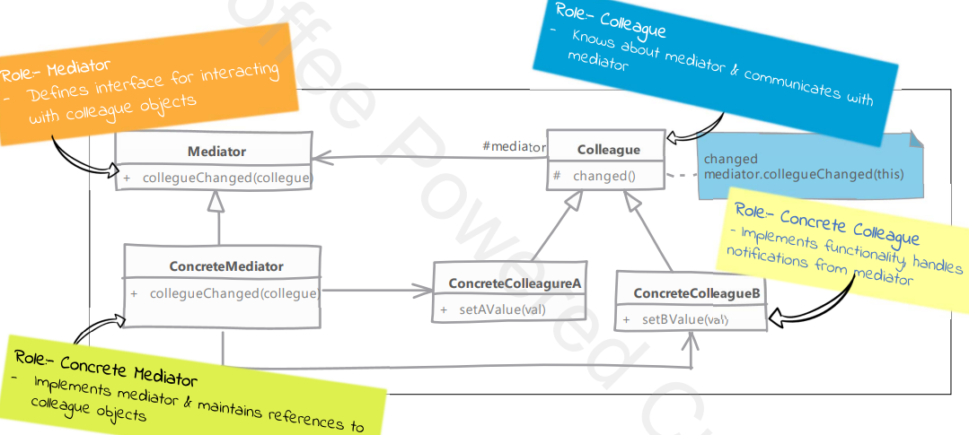

**Implementation steps:**

1. Defining mediator
   1. Mediators define a generic method which is called by other objects.
   2. This method typically needs to know which object changed and optionally the exact property which has changed in that object.
   3. Implement this method in which we notify rest of the objects about the state change.
2. Mediator needs to know about all participants in the collaboration it is mediating. To solve this problem, we can either have objects register with mediator or mediator itself can be the creator of these objects.
3. Depending upon your particular implementation you may need to handle the infinite loop of change-notify-change which can result if object’s value change handler is called for every value change whether from an external source as well as mediator.

**Intent:** lets you reduce chaotic dependencies between objects. The pattern restricts direct communications between the objects and forces them to collaborate only via a mediator object. Lowers the coupling of the classes, allowing them to be used by other classes.

**Real-World Analogy:** Pilots of aircraft that approach or depart the airport control area don’t communicate directly with each other. Instead, they speak to an air traffic controller, the mediator. Without the air traffic controller, pilots would need to be aware of every plane in the vicinity of the airport, discussing landing priorities with a committee of dozens of other pilots.

**Structure:**

